1. View Microsoft 365 account license and service details with PowerShell

Get-AzureADSubscribedSku | Select SkuPartNumber

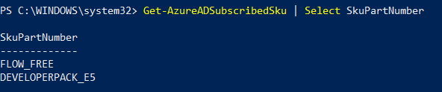

<https://docs.microsoft.com/en-us/microsoft-365/enterprise/view-account-license-and-service-details-with-microsoft-365-powershell?view=o365-worldwide>

1. View Microsoft 365 user accounts with PowerShell

Get-AzureADUser

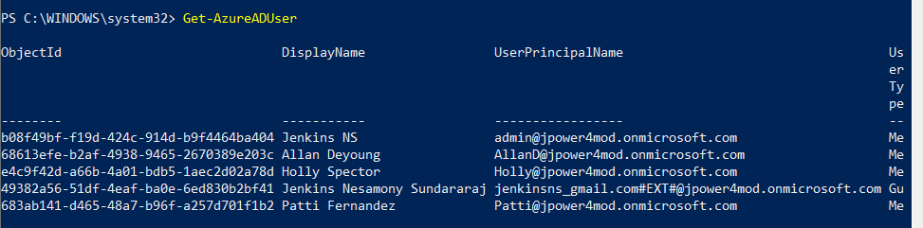

<https://docs.microsoft.com/en-us/microsoft-365/enterprise/view-user-accounts-with-microsoft-365-powershell?view=o365-worldwide>

<https://docs.microsoft.com/en-us/microsoft-365/enterprise/create-user-accounts-with-microsoft-365-powershell?view=o365-worldwide>

1. Assign license

<https://docs.microsoft.com/en-us/microsoft-365/enterprise/assign-licenses-to-user-accounts-with-microsoft-365-powershell?view=o365-worldwide#:~:text=You%20can't%20assign%20multiple,the%20available%20licenses%20run%20out>.

1. Create new security group

New-MsolGroup -DisplayName "MyGroup" -Description "My test group"

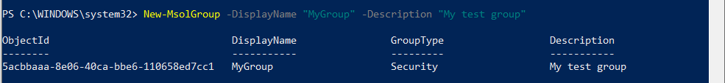

<https://docs.microsoft.com/en-us/powershell/module/msonline/?view=azureadps-1.0#msonline>

1. Create new Team, add users and add channel in MS Teams

New-Team -DisplayName "Tech Reads" -Description "Team to post technical articles and blogs" -Visibility Public

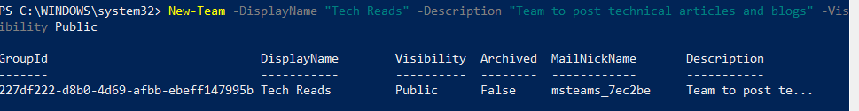

$group = New-Team -MailNickname "Wellsfargo" -displayname "Wellsfargo Team" -Visibility "private"

Add-TeamUser -GroupId $group.GroupId -User "Patti@jpower4mod.onmicrosoft.com"

Add-TeamUser -GroupId $group.GroupId -User "AllanD@jpower4mod.onmicrosoft.com"

Add-TeamUser -GroupId $group.GroupId -User "Holly@jpower4mod.onmicrosoft.com"

New-TeamChannel -GroupId $group.GroupId -DisplayName "Planning"

New-TeamChannel -GroupId $group.GroupId -DisplayName "Requirement"

New-TeamChannel -GroupId $group.GroupId -DisplayName "Development"

New-TeamChannel -GroupId $group.GroupId -DisplayName "Testing"

New-TeamChannel -GroupId $group.GroupId -DisplayName "UAT"

New-TeamChannel -GroupId $group.GroupId -DisplayName "Production"

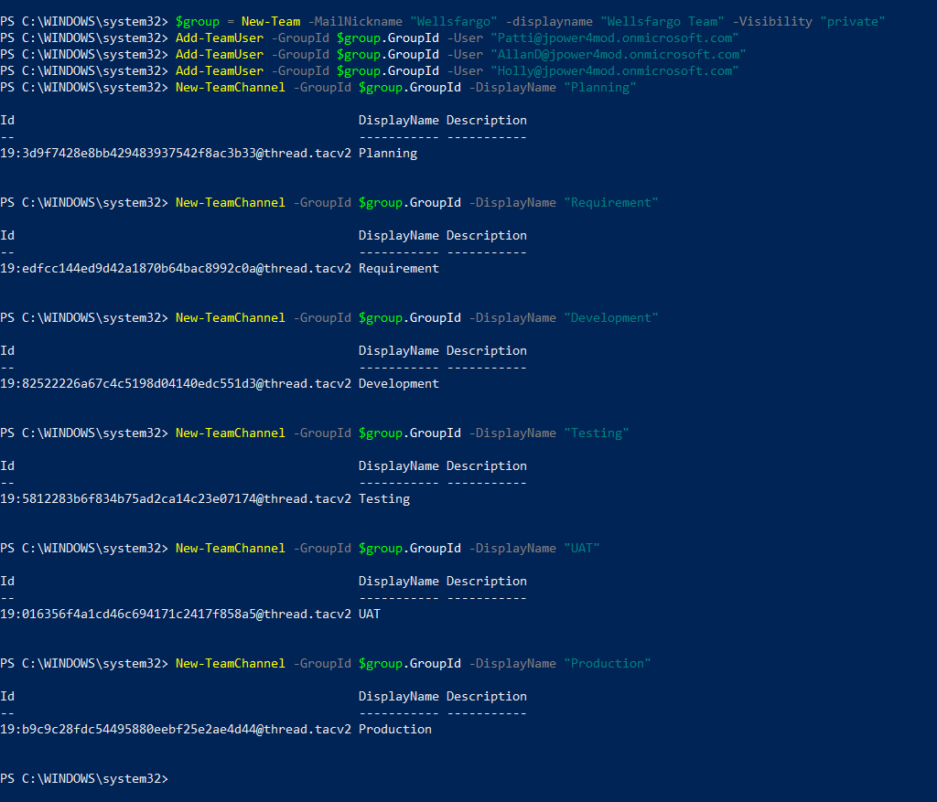

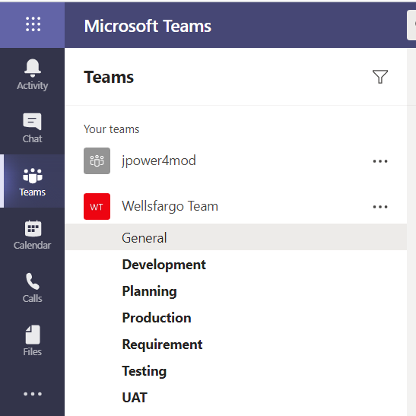

<https://docs.microsoft.com/en-us/powershell/module/teams/new-team?view=teams-ps>